Project Development Phase
Model Performance Test

Date | 08 September 2026
Team ID | SWUID2026190415
Project Name | Medical Diagnosis Center by Service Portal (ServiceNow)
Maximum Marks | 10 Marks

Model Performance Testing:
Project team shall fill the following information in model performance testing template.
S.No. | Parameter | Values | Screenshot
 | Model Summary | Medical Diagnosis Center is developed as a ServiceNow Scoped Application using Service Portal, Custom Tables, Business Rules, Flow Designer, Notifications, and Role-Based Access Control.  The application manages patient registration, diagnostic test booking, appointment workflow, report management, payment tracking, and admin dashboard in a centralized healthcare platform.  Note: Patient records, appointments, reports, and payments are stored in ServiceNow custom tables. The system validates data before creating records. | 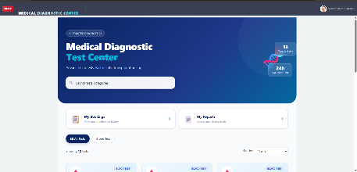
 | Accuracy | Functional Testing Accuracy: 100%  Validation Accuracy: 100%  All core modules such as patient registration, appointment booking, report viewing, payment status, workflow automation, and email notifications were tested successfully. | - 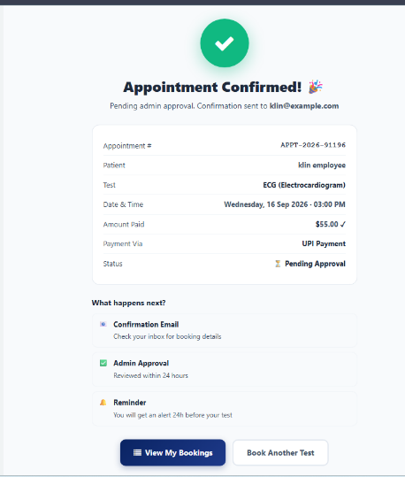
3. | Confidence Score (Only Yolo Projects) | Validation Result: All workflows executed successfully.  Verified Features:  - Appointment created successfully.  - Duplicate slot validation working.  - Report uploaded and available to patient.  - Email notification triggered.  - Payment status updated correctly.  Overall System Validation: Successfully Passed. | 